Saddleback High School’s Vision

Saddleback High School strives for excellence in meeting the needs of all students by designing unique learning experiences to generate excitement and growth for inquiry, as well as a celebration of individual differences and perspectives by providing a safe and inclusive environment which encourages open-mindedness.

Saddleback High School’s Mission

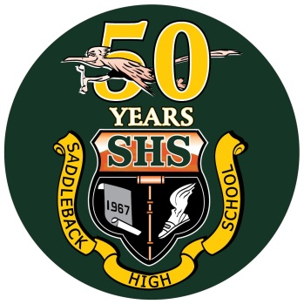Saddleback High School students will develop effective communication, collaboration and critical thinking skills, along with research techniques, and self-management strategies to become more balanced and reflective individuals. Additionally, we will work together to deliver rigorous instruction and personalized support to provide a successful transition to higher education and beyond, while promoting lifelong learning. The Saddleback staff and community will strive to create an awareness, understanding, and respect of individual and civic responsibilities, both locally and globally, in a multicultural, rapidly changing society.